Report for edificio de trabajo con consumo normal y optimizado

1. Time Series Characterization
Mean consumption: 17.66318537859008
Median consumption: 0.0
Std deviation: 33.49038898288145
Minimum consumption: 0
Maximum consumption: 322
95th percentile: 86.79999999999995
Total records: 383
Above Normal deviations: 18
Below Normal deviations: 0

2. Consumption Line Plot
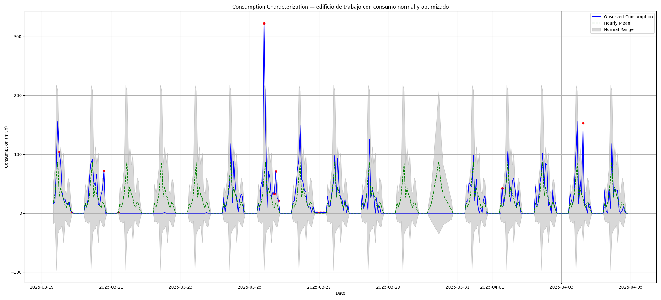

3. Deviation Heatmap
